Titanic Dataset — Data Cleaning and Exploratory Data Analysis

1. Introduction
Data Science involves collecting, cleaning, analysing, and visualising data. This project uses the Titanic passenger dataset to practise these steps using Python.

2. Objective
The objectives of this project are:
- To load a real-world CSV dataset using Pandas.
- To identify and handle missing values.
- To analyse passenger survival patterns.
- To create visualisations to understand the data.

3. Tools Used
- Python
- Google Colab
- Pandas
- Matplotlib

4. Data Acquisition
The Titanic dataset was loaded from an online CSV file using Pandas. The original dataset contained 891 rows and 12 columns.

5. Data Cleaning
Missing values were checked in every column. The missing Age values were filled using the median age. The missing Embarked values were filled using the most common boarding location. A new column called CabinKnown was created to indicate whether cabin information was available. The original Cabin values were retained.

6. Exploratory Data Analysis
The data was analysed to compare survival counts and survival rates by gender and passenger class. An age distribution histogram was also created to understand the age ranges of passengers.

7. Visualisations
- Survival Rate by Gender — bar chart.
- Survival Rate by Passenger Class — bar chart.
- Age Distribution of Titanic Passengers — histogram.
Insert the three graphs generated in Google Colab here.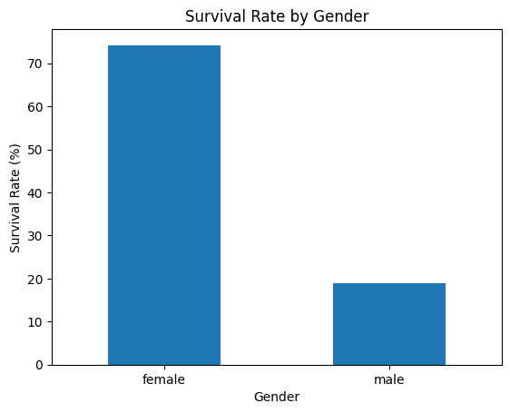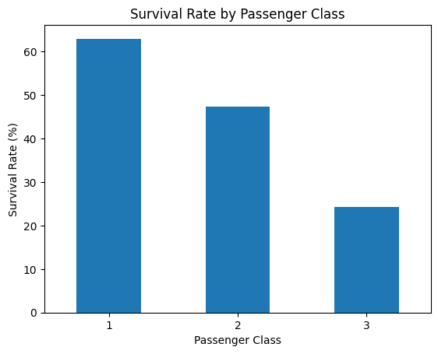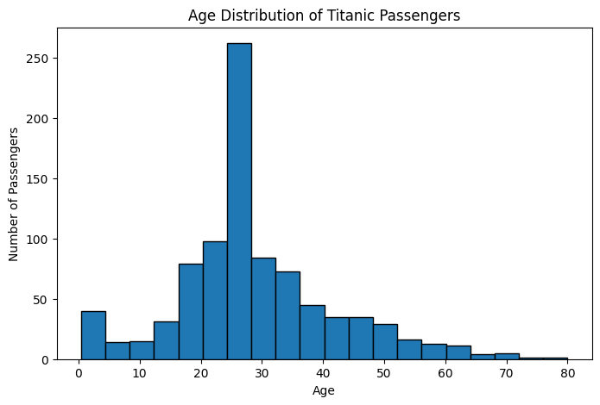

8. Conclusion
This project provided practical experience in loading a dataset, checking missing values, cleaning selected columns, performing exploratory data analysis, and creating visualisations. The analysis showed differences in survival rates across gender and passenger classes.

9. Learning Outcomes
I learned how to use Pandas to inspect and clean data, calculate summary statistics, group data into categories, and use Matplotlib to create charts.

